COURSE NAME : MICROPROCESSOR AND MICROCONTROLLERS
COURSE CODE : ECA1002
LAB PROGRAM EXECUTION

1. Arithmetic Operations in 8085 Microprocessors
a. 8-BIT ADDITION WITH CARRY USING DIRECT
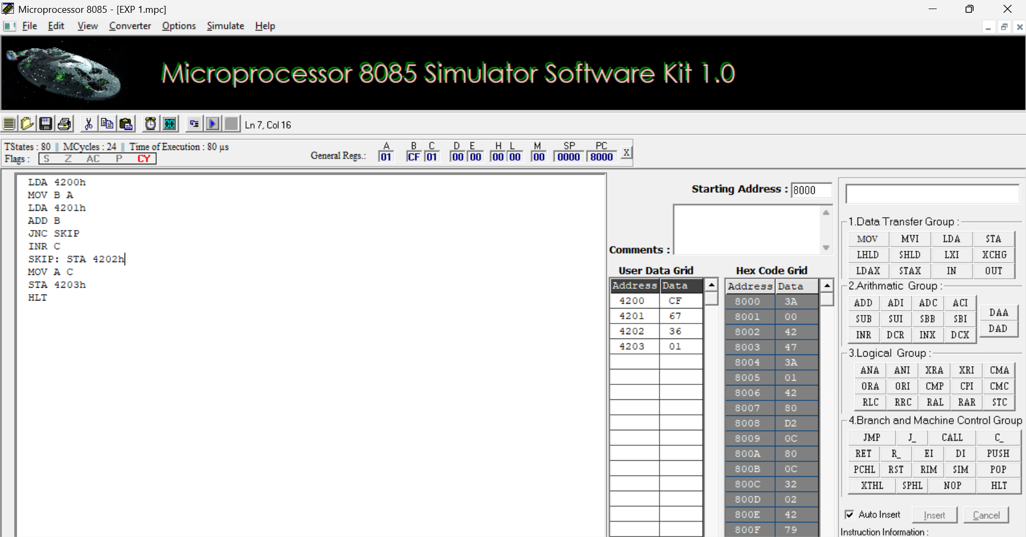

b. 8-BIT ADDITION USING INDIRECT ADDRESSING
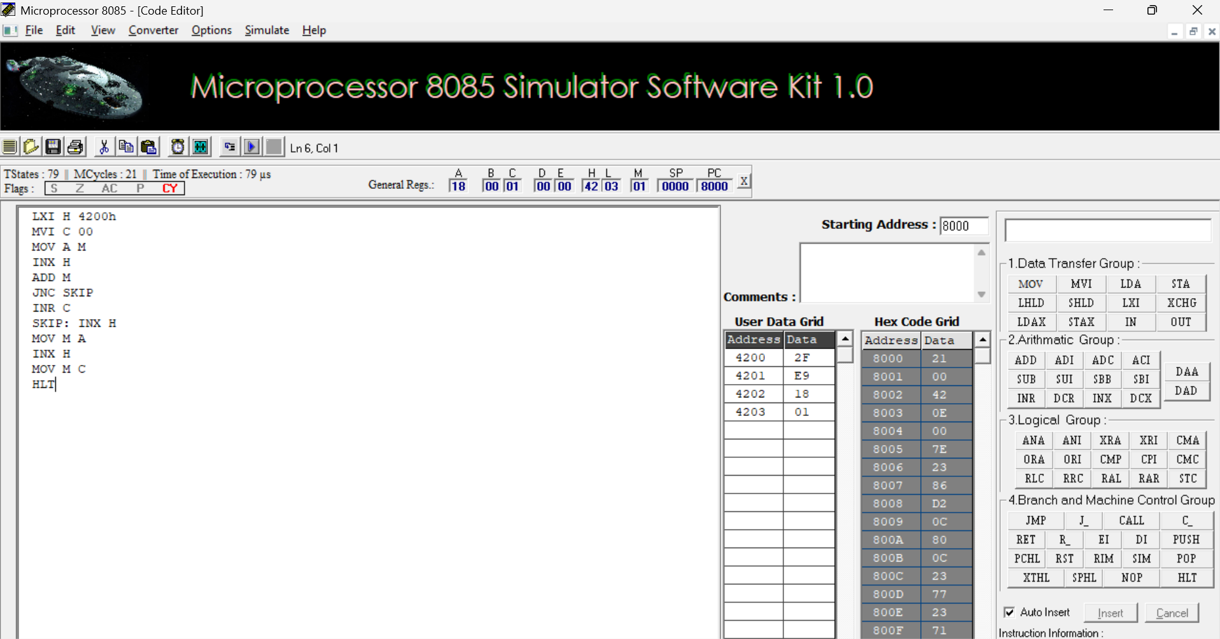
c. 8-BIT SUBTRACTION WITHOUT BORROW
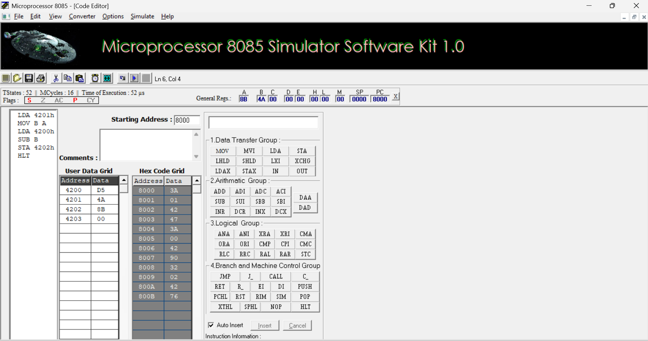

d. 8-BIT SUBTRACTION WITH BORROW USING DIRECT ADDRESSING
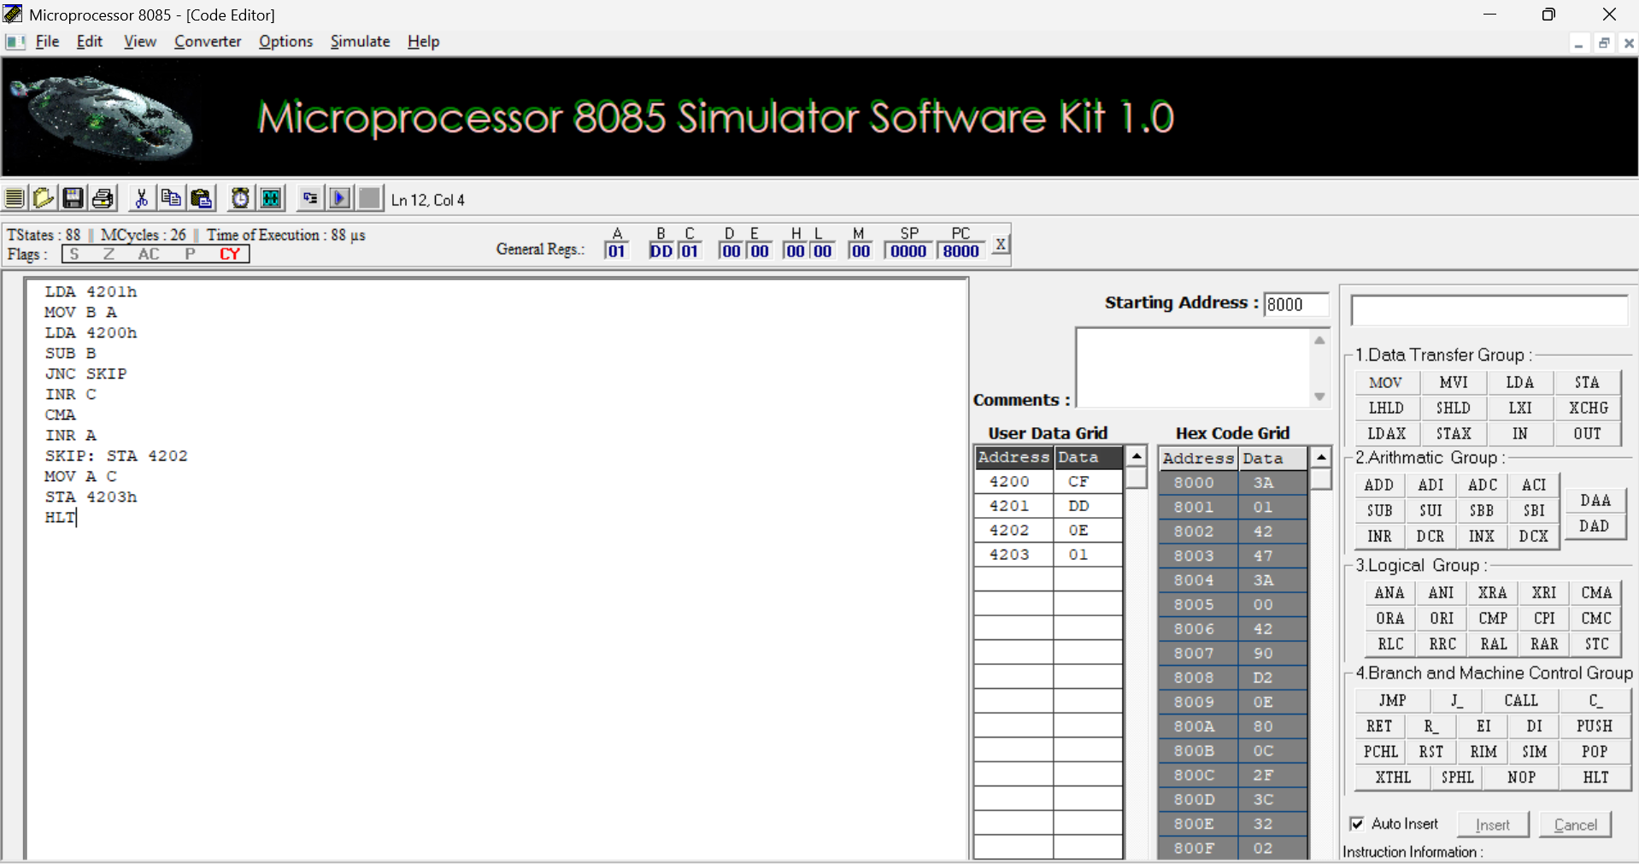

e. 8-BIT MULTIPLICATION OPERATIONS USING 8085 MICROPROCESSOR
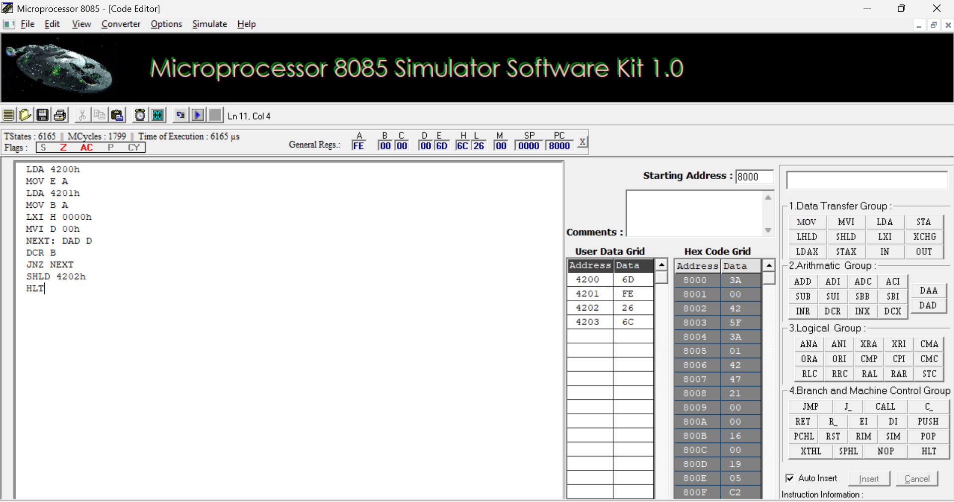

f. 8-BIT DIVISION OPERATIONS USING 8085 MICROPROCESSOR
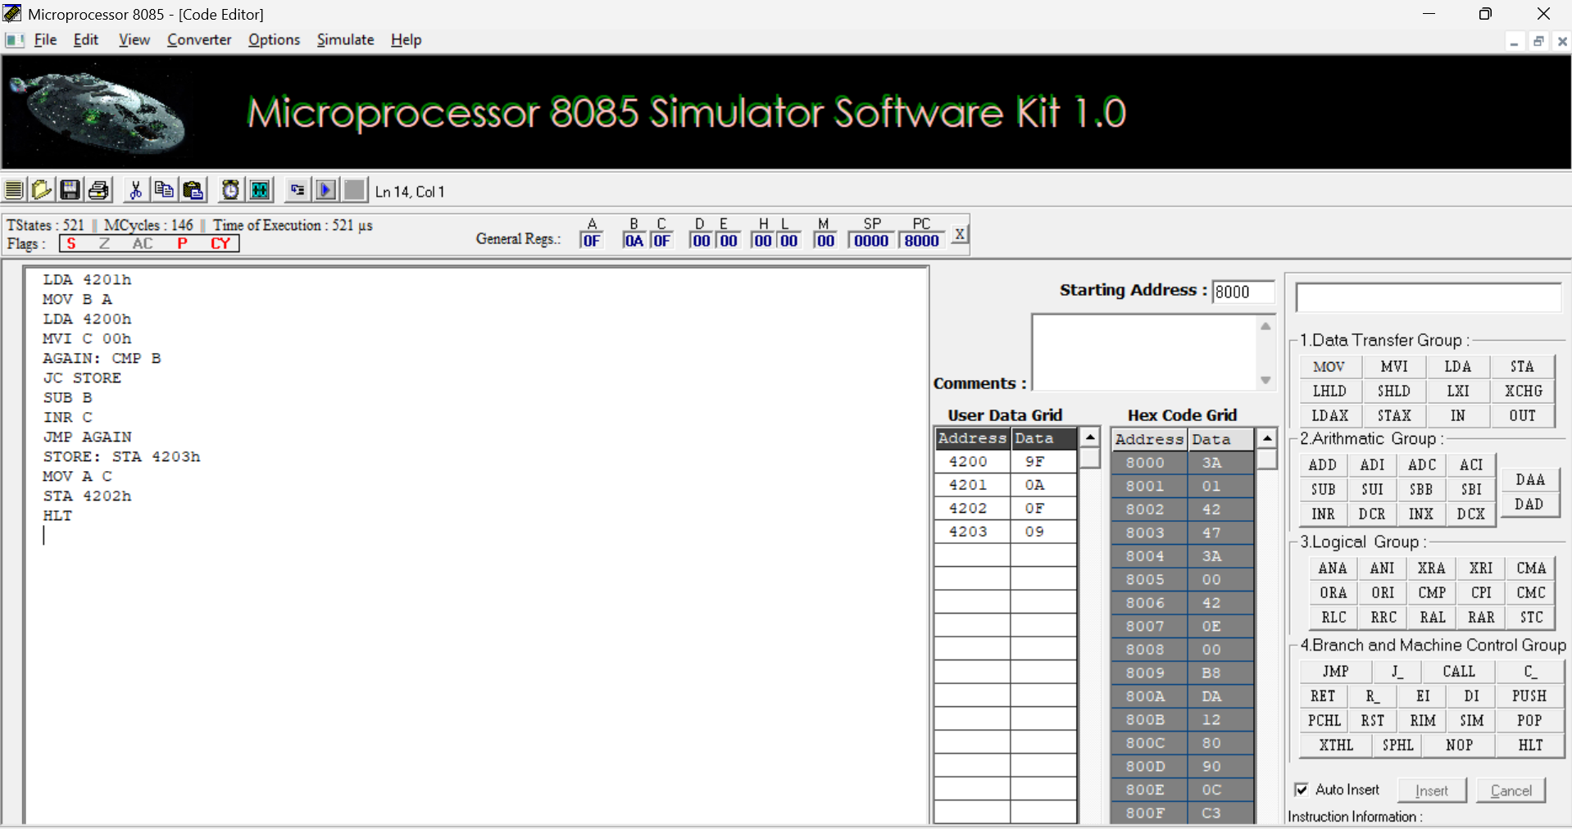

2.Ascending and Descending Order of an Unsorted Array using 8085
2a.SORT AN ARRAY OF DATA IN ASCENDING ORDER
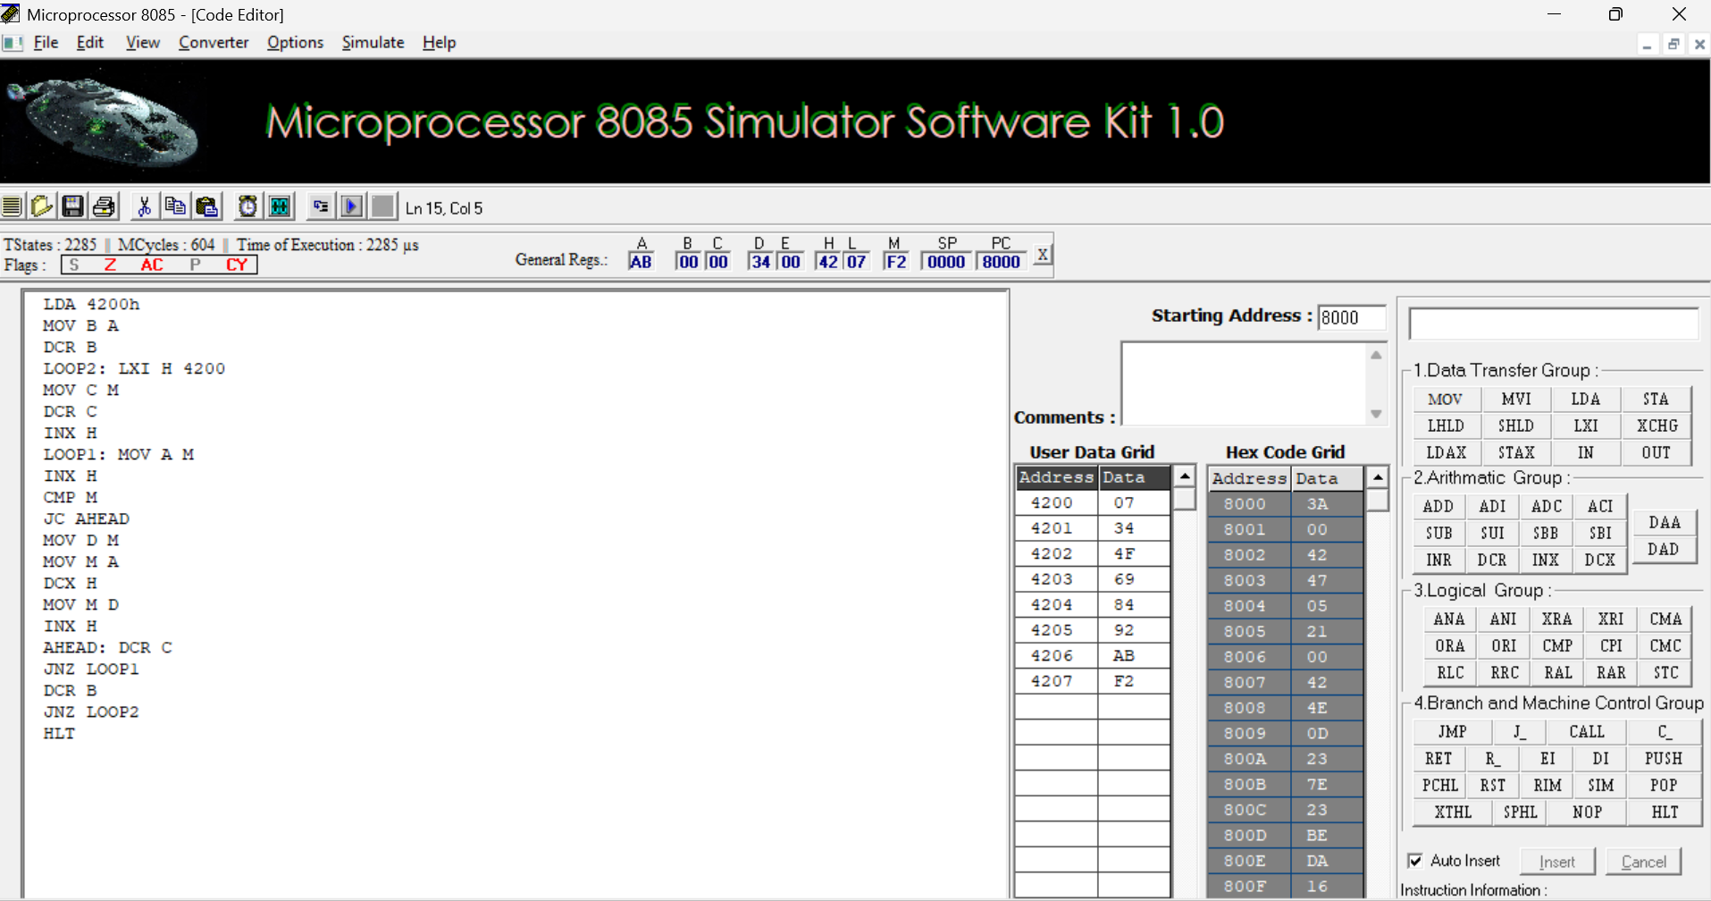

2b. SORT AN ARRAY OF DATA IN DESCENDING ORDER
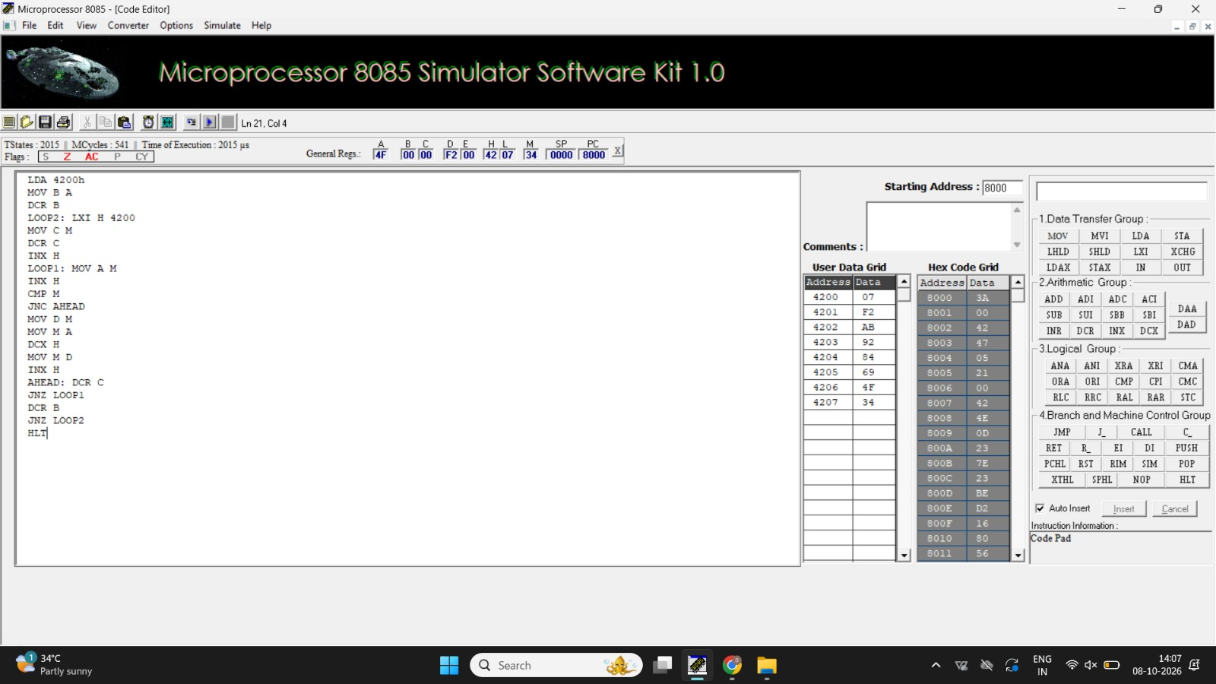

3.ASCII to HEX (Binary) Conversion using 8085 Microprocessor
1. ASCII CODE TO HEX CODE CONVERSION
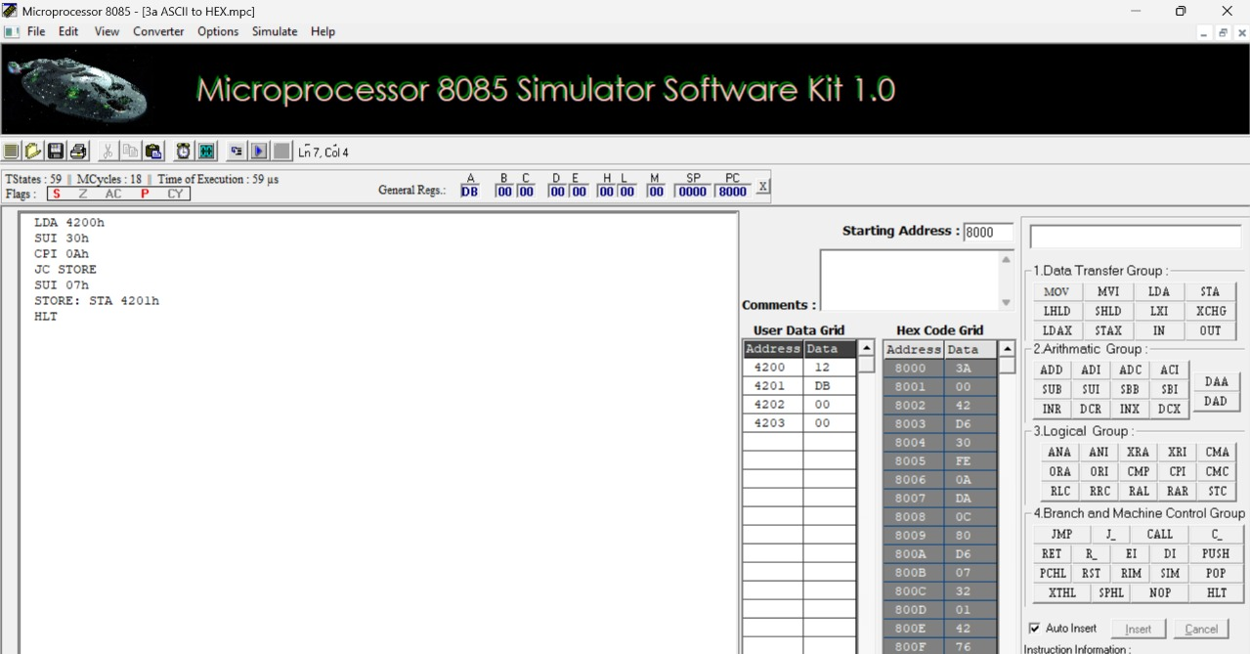

4. TRANSFERRING A BLOCK OF DATA BETWEEN MEMORY LOCATIONS
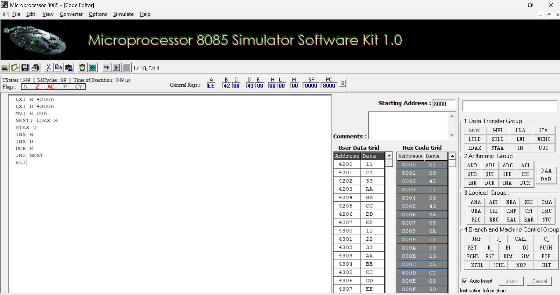

5. Perform Masking (AND), Setting (OR) of lower nibbles and One’s and Two’s
complement on given data using 8085 Microprocessor
5a. MASKING AND SETTING OF LOWER NIBBLES ON GIVEN DATA
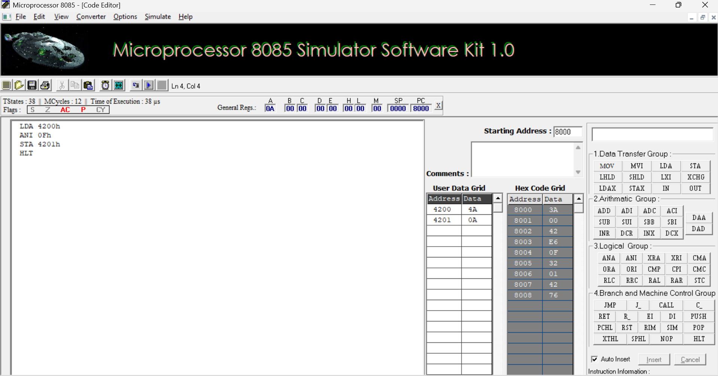

5b.ONE’S AND TWO’S COMPLEMENT
